Assignment 4 - Dashboard
The goal of this assignment is to create a dashboard for a measurement system. I used Tableau public to create my dashboard
I decided to use my readability assessment and use the results from the psf/black repository. After running the readability measurement and the information quality evaluation, I saved the results into csv files. I then used those csv files to create my dashboard.
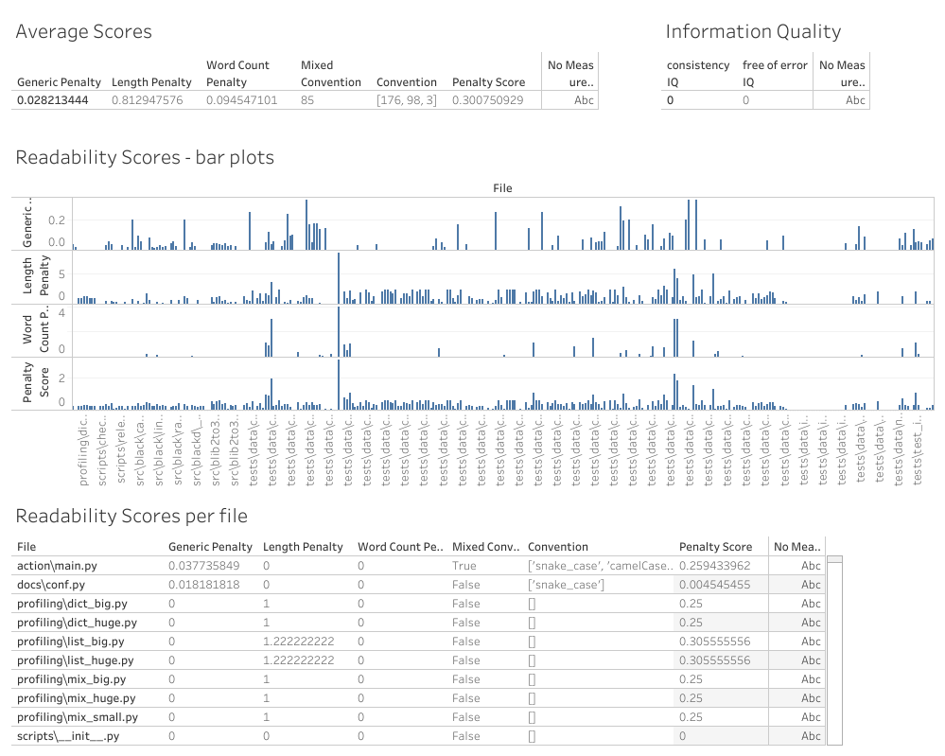
The top part of the dashboard contains the average penalties and score of the project and the information quality evaluation. The idea is that the top part contains the global results of the project.
The section in the middle contains bar plots for each of the 3 continuous penalties and the final penalty score for all files. This we can easily identify files that contains the highest penalties. The name of the files appears unreadable but clicking on any bars gives information about what file it corresponds to.
Finally, the last section contains a scrollable tab with all the results for every file. This part provides more detailed information and is intended to be used with filters to retrieve relevant information. In particular, it contains information about what convention are used in each file, which is not possible to see in the previous section since it is not a continuous information.

